/_api/web/lists/getbytitle(‘Staff’)/items?$filter=CDC_Email eq 'abc@cdc.gov'&$select=Title

/_api/web/lists/getbytitle(‘list name’)/items?$top=2105&$select=Id,UserFirstName,UserLastName

/_api/web/lists/getbytitle('list name')/items(420)

/_api/web/lists/getbytitle('Units')/items?$filter=Title eq 'XYZ'

Accept Application/json;odata=nometadata

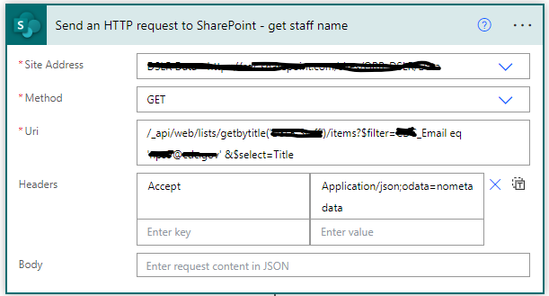

body('Send_an_HTTP_request_to_SharePoint_-_get_staff_name')['value']?[0]['Title']

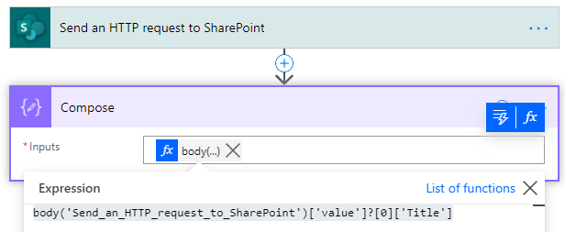

{

  "value": [

    {

      "Title": "John Lovett"

    }

  ]

}

Insert new SP list item – using POST Method

/_api/web/lists/getbytitle('ITT Calendar')/items

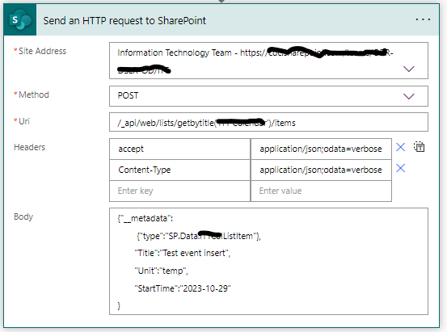

**Headers:**  
Content-Type: application/json;odata=verbose,

Accept: application/json;odata=verbose

**Body:**

{"__metadata":

{"type":"SP.Data.ITTCalListItem"},

"Title":"Test event insert",

"Unit":"temp",

"StartTime":"2023-10-29"

}

Update existing SP list item – using POST Method

*Using the list item ID*

Uri: /_api/web/lists/getbytitle('Staff')/items(1620)

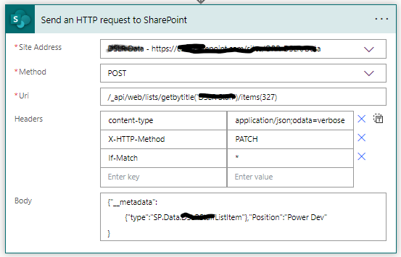

**Headers:**  
Content-Type: application/json;odata=verbose,  
X-HTTP-Method: PATCH,  
IF-MATCH: *

**Body:**  
{"__metadata":

{"type":"SP.Data.**Staff**ListItem"},"Position":"Power Dev"

}

Delete existing list item – with DELETE method

